

**FOOD MUNCH: A SIMPLE AND STATIC FOOD ORDERING WEB PAGE**

**A CAPSTONE PROJECT REPORT**

*Submitted to*

**SAVEETHA SCHOOL OF ENGINEERING**



Submitted by

**B. LAVANYA (192372046)**

**R. CHARITHA (192373007)**

Course Code: **CSA1086**

Course Name: Software Engineering for programming

**INDEX**

|  |  |  |
| --- | --- | --- |
| S.NO | TOPIC | PAGENO |
| 1 | ABSTRACT | 1 |
| 2.0 | INTRODUCTION | 1 |
|  | 2.1 Problem Statement | 1 |
| 2.2 Objectives | 1 |
| 3.0 | METHODOLOGY | 2 |
| 4.0 | DIRECTORY STRUCTURE | 3 |
| 5.0 | ADVANTAGES & APLLICATIONS | 3 |
| 6.0 | WEBSITE VISUALIZATION | 4,5 |
| 7.0 | RESULT & DISCUSSIONS | 6 |
| 8.0 | CONCLUSION | 7 |
| 9.0 | REPORT | 7 |

## 1.0 ABSTRACT:

The Buy Buddy platform is a revolutionary e-commerce website designed to provide an efficient, secure, and engaging shopping experience. Using an Agile Development Methodology, Buy Buddy iteratively develops and refines features based on real-time feedback, ensuring that the platform adapts to users' needs. The website focuses on providing a user-friendly interface, personalized recommendations, fast transaction processes, and robust security. This report outlines the methodology used for development, the platform’s objectives, advantages, and visual presentation, as well as a discussion of the results and final outcomes.

**2.0 INTRODUCTION:**

In the digital age, e-commerce has become an integral part of the shopping experience. However, users often encounter various challenges, including complicated navigation, lack of personalization, and security concerns. The Buy Buddy platform seeks to address these issues by providing a seamless, user-friendly, and secure online shopping environment. This report provides an overview of the methodology used, the challenges faced, and the objectives achieved during the development of Buy Buddy.

**2.1 Problem Statement**

E-commerce platforms face several challenges that hinder a smooth user experience, including:

* **Complicated navigation**: Users struggle with complex interfaces that make it difficult to find products and complete transactions.
* **Lack of personalization**: Many platforms offer a generic shopping experience, reducing engagement and customer retention.
* **Security concerns**: Users are often wary of providing payment information online due to fears about data breaches.
* **Inefficient transactions**: Slow and unreliable payment processes can frustrate users, resulting in cart abandonment.

Buy Buddy aims to overcome these challenges by offering a platform that is simple to navigate, personalized, secure, and efficient.

* 1. **Objectives**

The primary objectives of the Buy Buddy platform include:

1. **Simplified Navigation**: To create an intuitive interface where users can easily browse products and complete transactions.
2. **Personalized Recommendations**: To enhance user engagement by offering personalized product suggestions based on browsing behavior.
3. **Secure Transactions**: To implement robust security measures that protect user data and payment information.
4. **Optimized Performance**: To ensure fast load times and smooth interactions on the platform.

**3.0 METHODOLOGY:**

For the development of the Buy Buddy platform, **Agile Development Methodology** was employed. This iterative approach allows for continuous improvement and adaptation based on user feedback.

Key steps in the methodology include:

1. **Requirement Gathering**: Engaging with stakeholders to define the platform's goals and features, such as user-friendly navigation and secure payment gateways.
2. **Planning**: Defining the project scope, deliverables, and timelines, prioritizing features based on user needs.
3. **Design and Prototyping**: Creating wireframes and mockups for the website’s interface, ensuring a user-friendly and responsive design.
4. **Development**: Implementing features in iterative cycles, focusing on key aspects like navigation, product recommendations, and payment integration.
5. **Testing**: Conducting various tests (unit, integration, UAT) to ensure functionality, performance, and security.
6. **Deployment**: Launching the platform, monitoring for issues, and ensuring continuous performance optimization.
7. **Feedback and Iteration**: Collecting user feedback and making necessary improvements in subsequent development sprints.

**1. Requirements Gathering and Analysis**

* The requirements for the Buy Buddy platform were gathered through stakeholder discussions and user surveys to understand the challenges faced in e-commerce.
* Key areas of focus included:
  + Simplifying the navigation structure for an intuitive user experience.
  + Implementing personalized product recommendations to enhance engagement.
  + Ensuring robust security for transactions and user data.
  + Optimizing performance for faster load times and seamless interactions.
* A detailed requirement document was prepared, prioritizing features based on user needs and technical feasibility.

**2. System Design**

* A blueprint of the system architecture was created to outline the overall structure and flow of the platform.
* Design elements included:
  + Frontend Design: Wireframes for a responsive and user-friendly interface, including a homepage, product pages, cart, and checkout pages.
  + Backend Design: Database schema for storing user data, product information, and transaction details.
  + Security Design: SSL encryption for secure communications and payment gateway integration.
  + Recommendation Engine: Basic architecture for implementing machine learning algorithms for personalized suggestions.
* Prototypes were developed and reviewed with stakeholders for alignment.

**3. Implementation**

* The platform was developed incrementally using Agile sprints:
  + Frontend: HTML, CSS, and JavaScript were used to create the interface, ensuring responsive design.
  + Backend: A server-side framework (e.g., Node.js or Java) was used for business logic, while the database (e.g., MySQL or MongoDB) was implemented for data management.
  + Recommendation System: Initial recommendation algorithms using collaborative filtering and browsing history.
  + Security Features: Integration of encryption and secure authentication mechanisms.
* Each feature was implemented in manageable cycles to ensure focus and flexibility.

**4. Integration and Testing**

* Integration: Individual components (frontend, backend, database, and APIs) were integrated to form a cohesive platform.
* Testing:
  + Unit Testing: Ensured each module (e.g., product search, cart operations) worked independently.
  + Integration Testing: Verified seamless communication between components.
  + User Acceptance Testing (UAT): Involved end-users to test the interface and functionality in real-world scenarios.
  + Performance Testing: Tested the website’s load times and scalability under high traffic.
  + Security Testing: Conducted vulnerability assessments to ensure data safety.

**5. Deployment**

* The platform was deployed to a cloud hosting environment (e.g., AWS, Azure, or GCP) for scalability and reliability.
* Deployment included:
  + Configuring servers and setting up the production environment.
  + Implementing a Content Delivery Network (CDN) for faster load times globally.
  + Launching the platform with monitoring tools to track performance and usage.

**6. Maintenance**

* Continuous Monitoring: Performance metrics such as response time, server load, and user activity were tracked.
* User Feedback: Regularly collected to identify areas of improvement and bugs.
* Feature Updates:
  + Introducing new features like advanced search, additional payment options, or promotional tools.
  + Periodic updates to the recommendation engine for better accuracy.
* Security Maintenance: Regular updates to encryption algorithms, patching vulnerabilities, and compliance with data protection regulations.

**4.0 DIRECTORY STRUCTURE:**

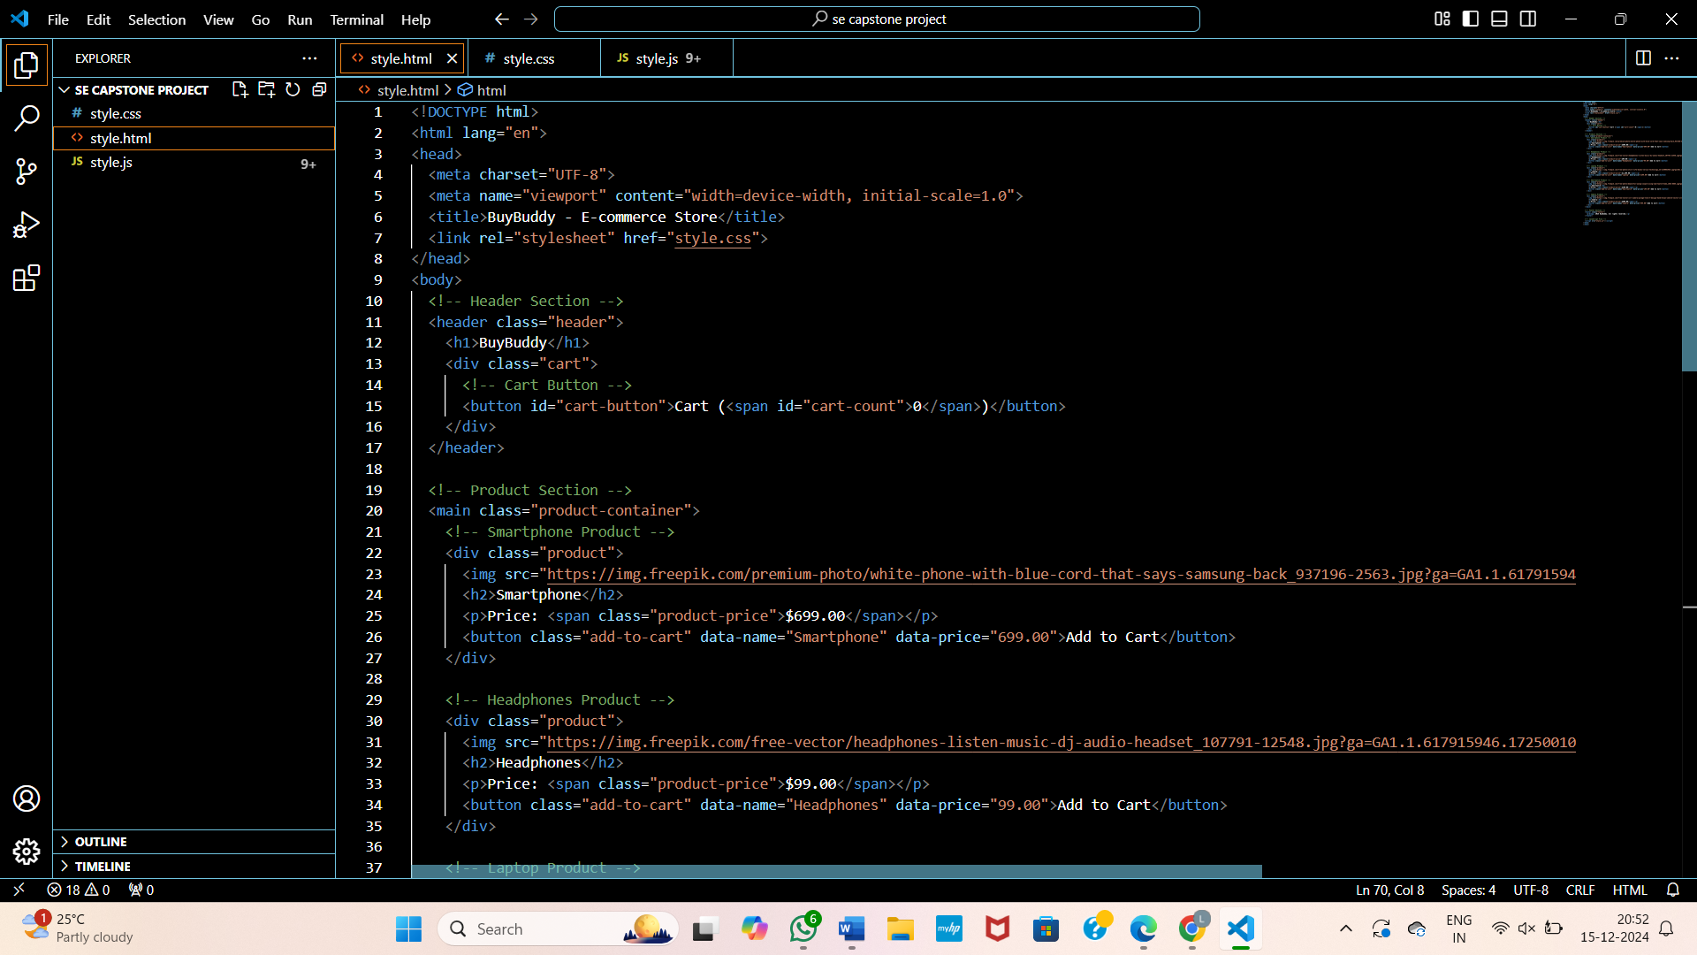

**5.0 ADVANTAGES & APPLICATIONS:**

**Advantages**:

* **User-Centric Design**: By focusing on simplicity and personalization, Buy Buddy offers an enhanced shopping experience.
* **Scalability**: Built using modern web technologies, Buy Buddy can scale as the user base grows.
* **Security**: Strong encryption and secure payment gateways protect user data and transactions.
* **Agile Development**: The iterative approach ensures continuous improvement, addressing user concerns and introducing new features.

**Applications**:

* **Retailers**: Allows businesses to showcase their products and reach a wider audience.
* **Consumers**: Provides a fast, secure, and personalized shopping experience.
* **Data Analysts**: Enables tracking of user behavior to improve product offerings and marketing strategies.

**Practical Applications**

1. **Effortless Product Discovery**:  
   Users can quickly find products using a clean, intuitive navigation bar and advanced search filters.
2. **Personalized Recommendations**:  
   AI-driven suggestions help users discover relevant products based on their browsing and purchase history.
3. **Secure Transactions**:  
   Integration with payment gateways like PayPal or Stripe ensures data safety and user trust.
4. **Responsive Design**:  
   The platform is accessible on desktops, tablets, and mobile devices for a seamless shopping experience.
5. **Efficient Order Processing**:  
   A streamlined checkout process reduces cart abandonment and enhances user satisfaction.
6. **Scalable Architecture**:  
   The platform can handle increasing traffic and product listings, making it suitable for growing businesses.
7. **Feedback-Driven Updates**:  
   Continuous improvements based on user feedback ensure the platform evolves with customer needs.

**6.0 WEBSITE VISUALIZATION:**

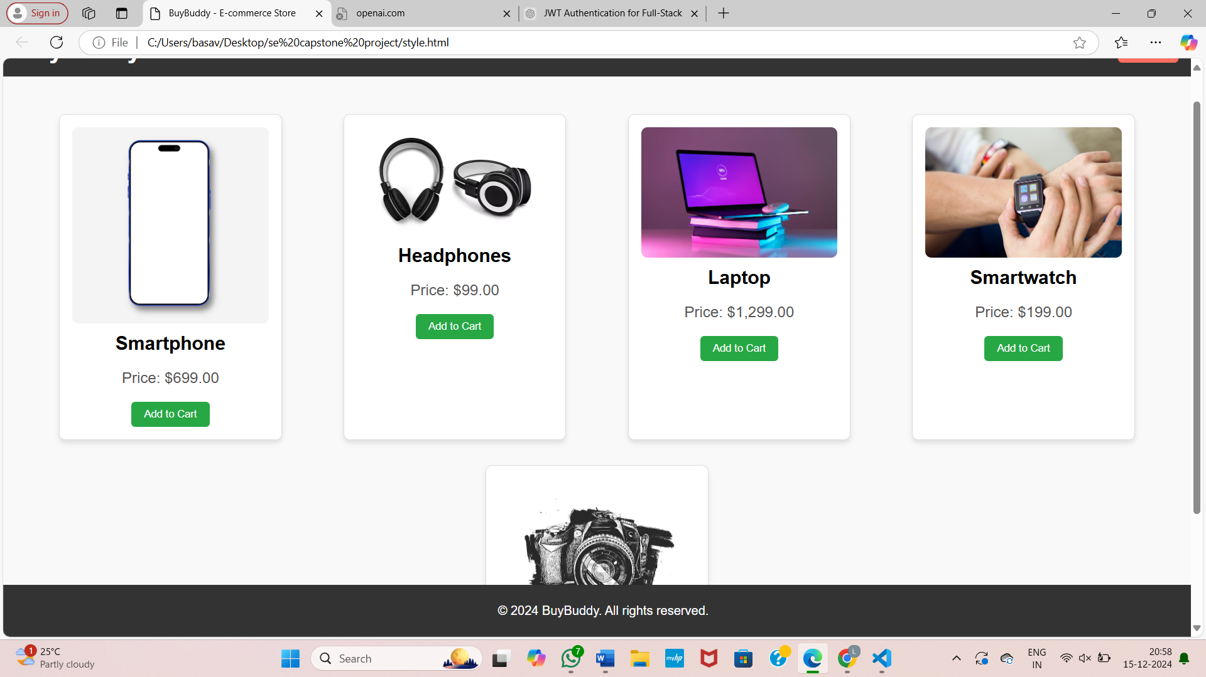

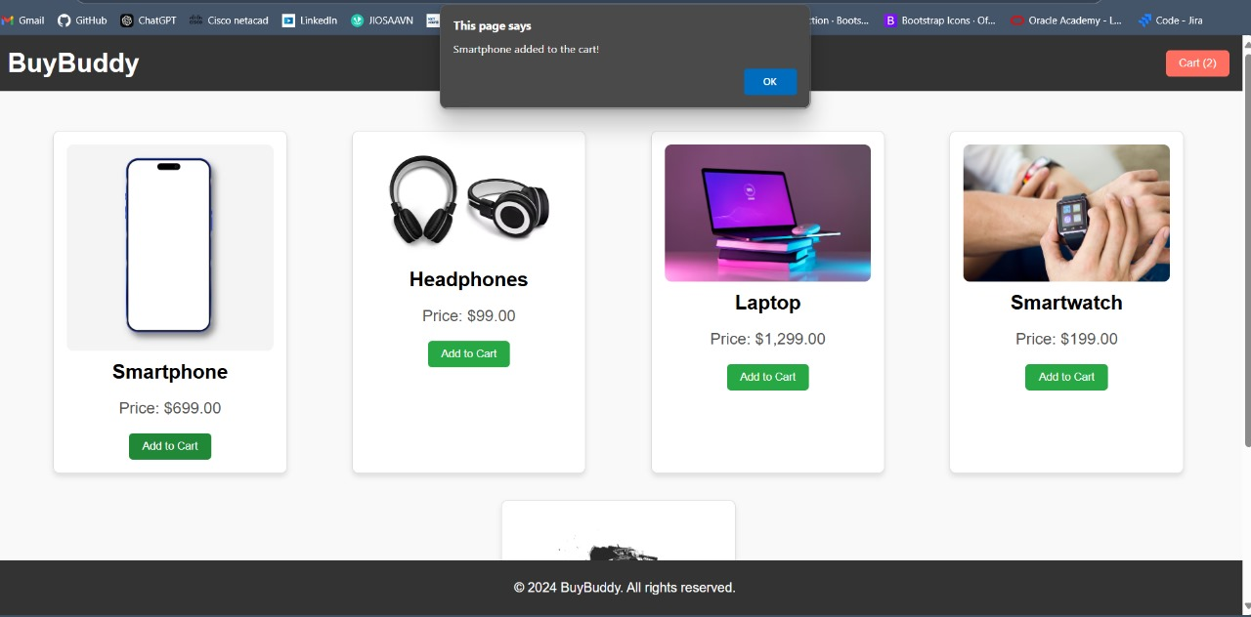

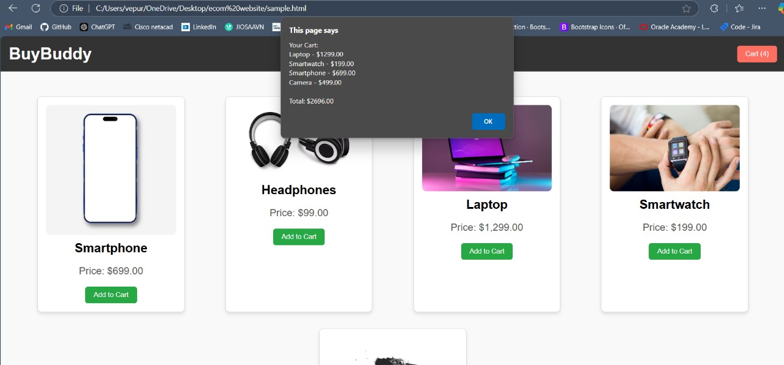

**7.0** **RESULTS & DISCUSSION:**

The Buy Buddy platform has successfully addressed the challenges outlined in the problem statement. Key results include:

* Enhanced User Experience: The intuitive navigation and personalized recommendations have increased user engagement and satisfaction.
* Security Improvements: The implementation of SSL encryption and secure payment gateways has built trust among users.
* Faster Transactions: Optimized checkout processes and payment integration have reduced transaction times and cart abandonment.
* Positive User Feedback: Early user testing has shown high levels of satisfaction with the platform’s performance and ease of use.

**8.0 CONCLUSION**

The Buy Buddy platform, developed using the Agile methodology, has successfully created a user-friendly, personalized, and secure e-commerce environment. By focusing on iterative development and continuous feedback, Buy Buddy addresses the common issues faced by e-commerce platforms today. The project has demonstrated the importance of user-centric design and robust security measures in delivering a successful online shopping experience.

**9.0 REPORT**

This report has provided an overview of the Buy Buddy platform’s development process, objectives, methodology, and outcomes. It highlights the effectiveness of using Agile Development to create a flexible and user-focused e-commerce website. The continuous improvement model employed will ensure that Buy Buddy remains a competitive and reliable platform for users in the rapidly evolving e-commerce market.